FA2 Report

FA2 Report
- Student Name: Prakhar Sharma
- Candidate Registration Number: 1000260
- CRS Name: Artificial Intelligence
- Course ID: IADAI204
- Course Name: The Art of Storytelling with Data
- School Name: Ryan Global School, Kharghar
Project Title: Airbnb Urban Tourism Data Dashboard

Github Link:
Tableau Link: https://public.tableau.com/views/Airbnb_Urban_Tourism_Dashboard/Dashboard1?:language=en-US&:sid=&:redirect=auth&:display_count=n&:origin=viz_share_link

1. Introduction
This project is based on the concept of storytelling with data using Tableau. The aim of this assignment was to analyze Airbnb urban tourism data and present meaningful insights through visual storytelling. Instead of showing raw numbers and tables, the dashboard was designed to communicate patterns related to pricing, room types, locations, and availability in a clear and visual format.
Storytelling with data helps in simplifying complex datasets and making them easy to understand. Through this project, the Airbnb dataset was transformed into interactive visualizations that explain tourism and accommodation trends effectively.

2. Objective of the Project
The main objective of this project was to analyze Airbnb listing data and create an interactive dashboard that highlights important tourism patterns. The goal was to understand how factors like city, room type, and price influence Airbnb listings and user choices.
Another objective was to apply data storytelling principles by organizing visualizations in a logical flow so that users can easily interpret insights from the dashboard.

3. Data Source and Data Preparation
The dataset used for this project was the Airbnb Urban Tourism dataset (AB_US_2023.csv).
This dataset included key information such as:
- City
- Price
- Room Type
- Availability
- Number of Reviews
- Listing Details
The data was imported into Tableau and basic preparation was done before visualization. This included:
- Checking and selecting relevant fields
- Handling missing values
- Organizing dimensions (City, Room Type) and measures (Price, Reviews)
- Ensuring proper data types for accurate analysis
This step helped in creating clean and reliable visualizations.

4. Methodology and Tools Used
Tableau was used as the primary tool for data visualization and dashboard creation. The methodology followed a structured approach.
First, the dataset was connected in Tableau. After that, multiple worksheets were created to analyze different aspects of the Airbnb data. These included:
- Price analysis by city
- Room type distribution
- Availability trends
- Review and listing comparisons
Filters such as City, Room Type, and Price were added to make the dashboard interactive. Finally, all the sheets were combined into a single dashboard layout to tell a complete data story.

5. Dashboard Description
The Airbnb Urban Tourism Dashboard presents a visual analysis of Airbnb listings across different cities. It includes charts that show price variations, room type distribution, and listing patterns.
The dashboard is interactive and user-friendly. Users can apply filters to explore data based on city and room type. The layout is clean and structured so that viewers can easily understand the information without confusion.
The design follows storytelling principles, where each chart contributes to explaining tourism trends and accommodation patterns in urban areas.

6. Key Insights from the Dashboard
Based on the visual analysis, the following insights were observed:
- Prices of Airbnb listings vary significantly across different cities.
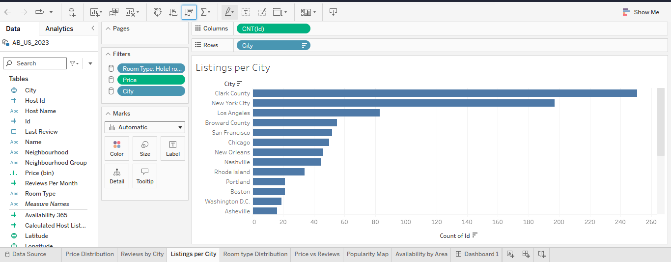
- Entire homes/apartments are generally priced higher than private rooms.
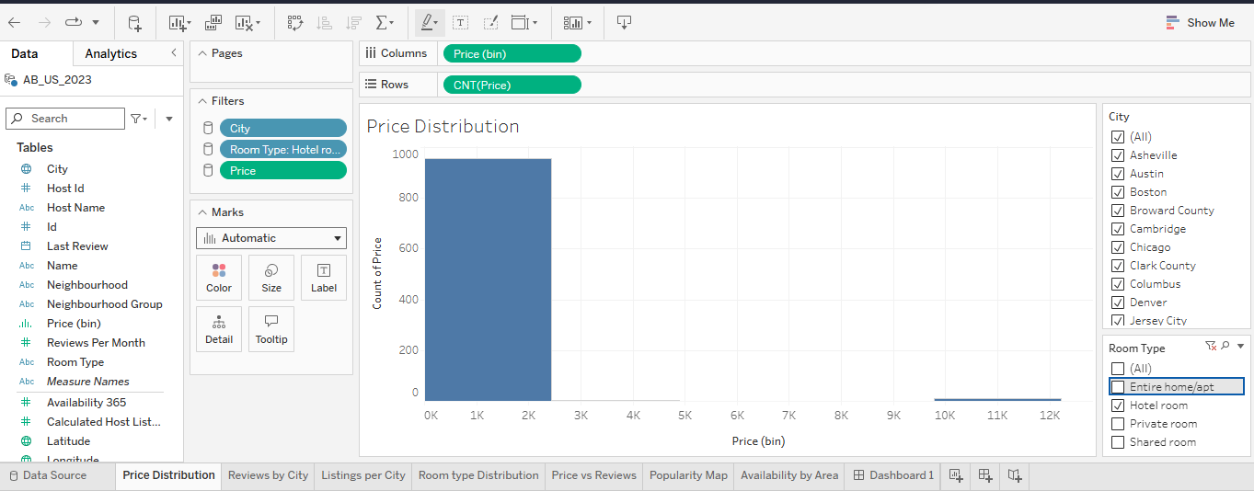
- Some cities have a higher number of listings, indicating strong tourism demand.
- Availability and pricing patterns reflect tourist preferences and urban demand.
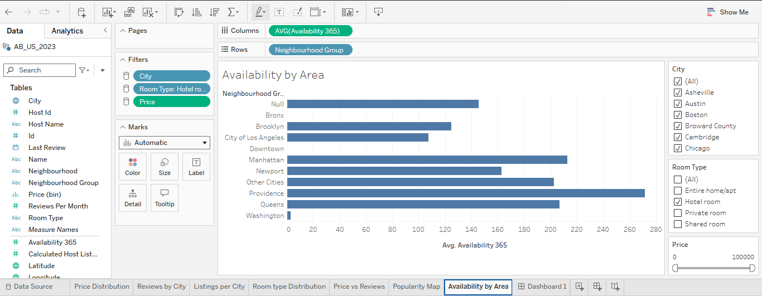
- Data visualization makes it easier to compare room types and pricing trends.
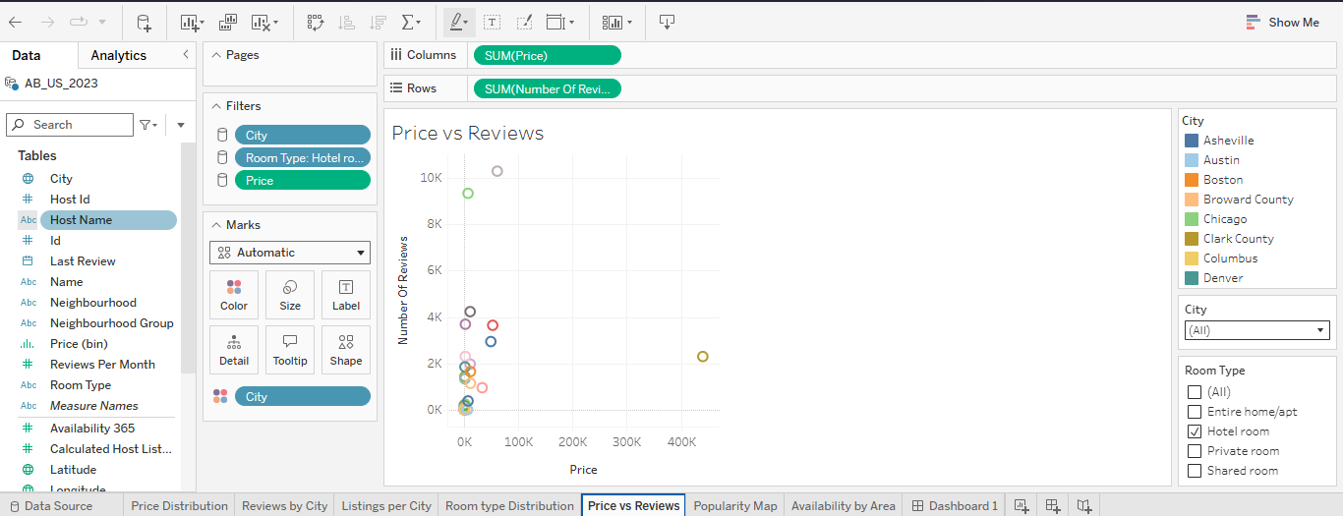
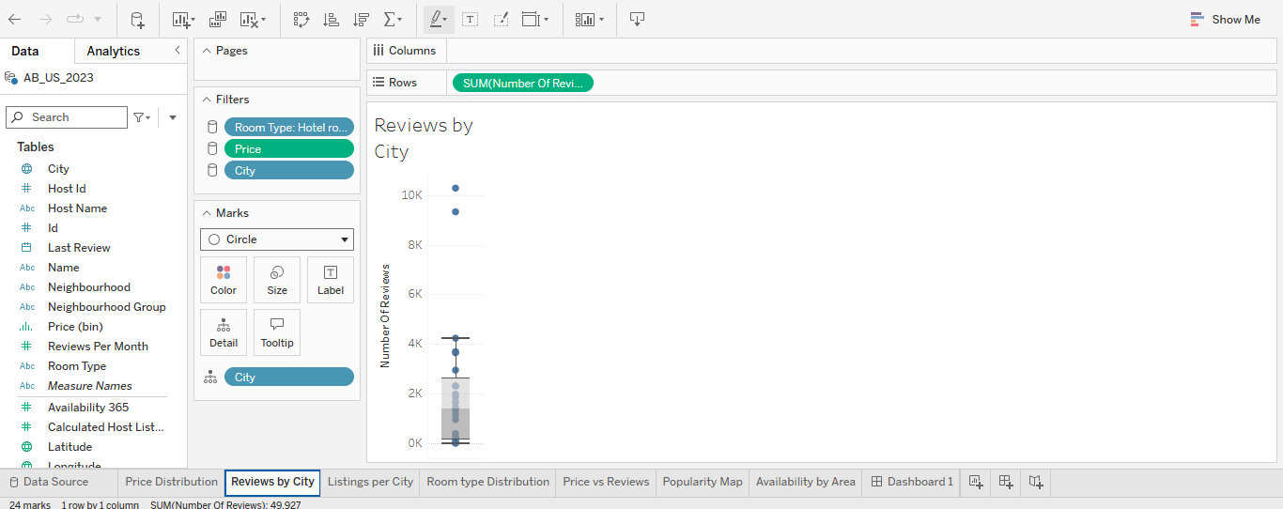
Dashboard Image:
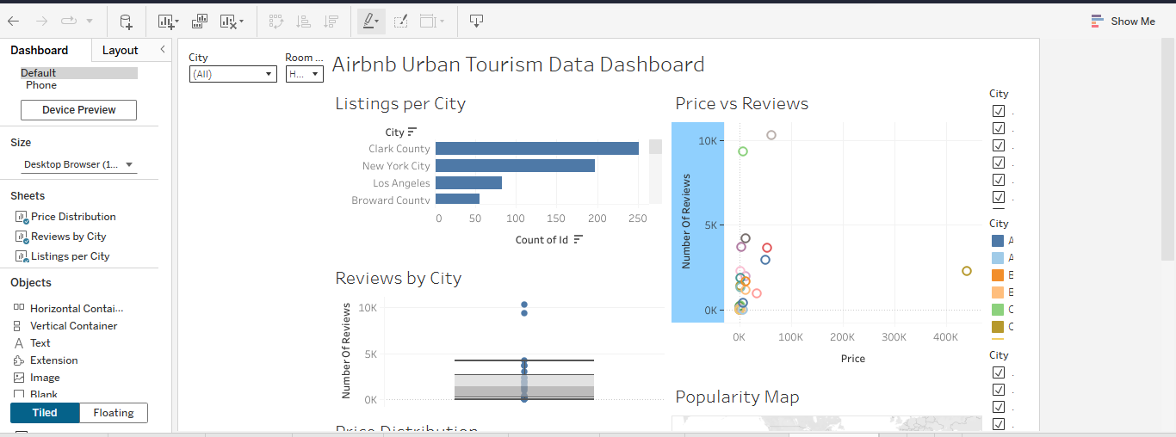
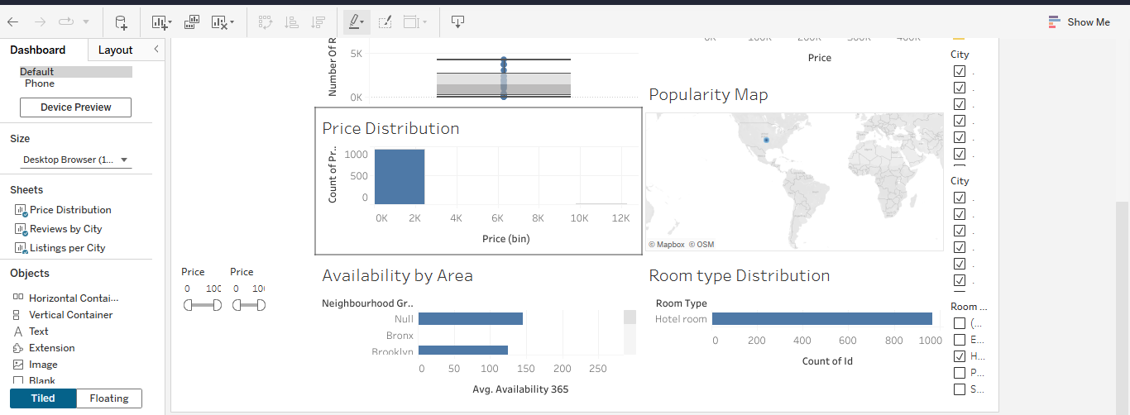
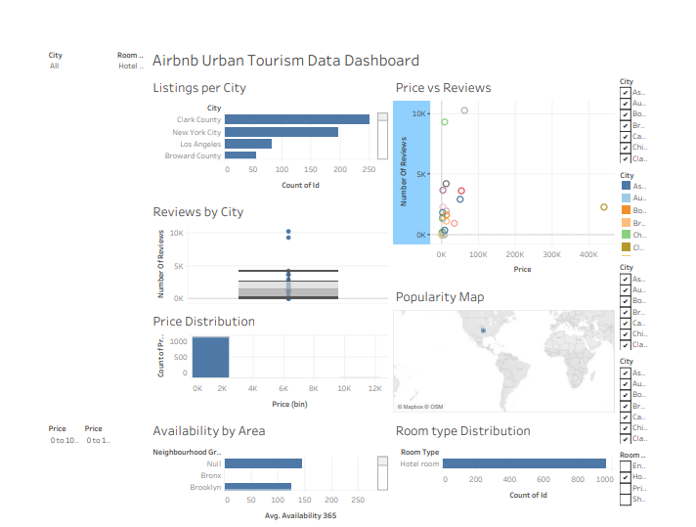
These insights clearly show how urban tourism impacts Airbnb listing behavior.

7. Reflection
Through this project, I learned how data storytelling can transform raw tourism data into meaningful visual insights. Initially, working with the Airbnb dataset was challenging because it contained multiple variables and large amounts of information. Understanding which fields to use and how to structure the dashboard required careful planning.
While creating the dashboard, I developed practical skills such as connecting datasets, using filters, organizing dimensions and measures, and designing an interactive layout in Tableau. One of the main challenges I faced was arranging the visualizations in a way that tells a logical and engaging story. By improving the dashboard structure and selecting suitable chart types, I was able to make the visuals more clear and informative.
This project enhanced my analytical thinking, visualization skills, and understanding of user-friendly dashboard design. I also realized that visual storytelling is much more effective than presenting raw data in tables. Overall, this assignment improved my confidence in Tableau and strengthened my ability to communicate insights through data visualization.

8. Conclusion
In conclusion, the Airbnb Urban Tourism Dashboard successfully demonstrates the application of storytelling with data. The project effectively converts raw Airbnb listing data into clear, interactive, and meaningful visual insights.
The dashboard helps in understanding pricing patterns, room type distribution, and tourism trends in urban areas. This project fulfills the objective of the assignment by presenting data in a structured, visual, and easy-to-understand storytelling format while showcasing strong analytical and visualization skills.

